

**AMERICAN INTERNATIONAL UNIVERSITY – BANGLADESH**

**FACULTY OF SCIENCE & TECHNOLOGY**

**DEPARTMENT OF PHYSICS**

**PHYSICS LAB**

**Spring 2021-2022**

**Section: B21, Group:08**

**LAB REPORT ON**

To determine the projectile motion and collision of a ball.

**Supervised By**

Dr. Md. Rayhan Uddin

**Submitted By**

|  |  |  |
| --- | --- | --- |
| Name | ID | Contribution |
| 1. BIDHAN SAHA | 22-47153-1 | Theory |
| 2. RIFAH SANZIDA | 22-47154-1 | Experimental data |
| 3. MD ABDULLAH AL  NOMAN | 22-47155-1 | Analysis and Calculation |
| 4. SHAYAN ABRAR | 22-47156-1 | Result |
| 5. ASADUZZAMAN  SAYMON | 22-47158-1 | Discussion , References |

Date of Submission: February 26, 2022

**TABLE OF CONTENTS**

**TOPICS**   **Page no.**

1. **Title Page 1**
2. **Table of Content 2**
3. **Theory**  **3**
4. **Apparatus 4**
5. **Procedure 5**
6. **Experimental Data 6**
7. **Analysis and Calculation 7**
8. **Result 8**
9. **Discussion 9**
10. **References 9**

**1. Theory**

**Projectile Motion:**

The motion of projectiles, known to mankind since the times of Archimedes, is an example of two-dimensional motion. This motion occurs in a vertical plane defined by the direction of launch. In the simplest case (when air resistance is neglected and motion occurs close to the surface of earth), the projected body experiences a uniform acceleration along the vertical direction and a uniform velocity along the horizontal direction.

The trajectory of a projectile is parabolic as the fig. 3.1 shows. A study on projectile motion helps in a thorough understanding of the basic concepts in kinematics like accelerated motion, uniform motion, equations of motion and so on.

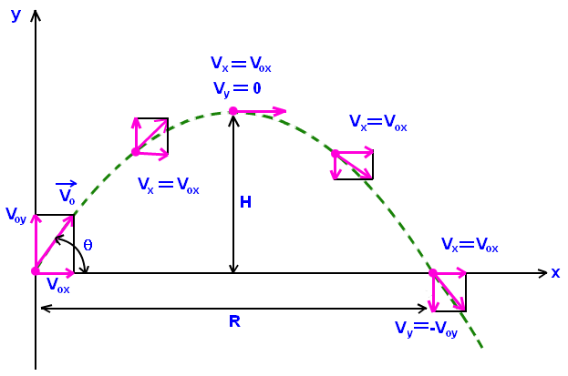

Figure 3.1: The parabolic trajectory of a projectile in the x-y plane. The projectile is thrown with an initial velocity v0 and angle θ with the x axis. R and H represent the range and maximum height of the projectile, respectively.

**Collision:**

The elastic collision between a ball and a fixed smooth surface can be presented as the fig.3.2 shows.

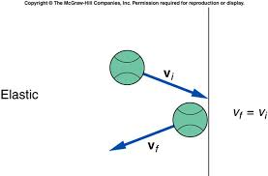

Figure 3.2: An elastic collision between a smooth ball and a table. The velocities just before and after the collision remain the same.

For an elastic collision, both the momentum and kinetic energy are conserved. The impulse in any dimension (x or y) can be defined as

Impulse, J = Change in momentum, Δ p = pf – pi,

where pi and pf are the initial and final momentum, respectively.

**2.** **Apparatus**

* Marble
* Ramp
* Clamp
* Recording paper
* Carbon paper
* Meter scale
* Weighing scale

**3. Procedure**

* We set up the apparatus as shown in fig. 3.3. We make sure that the end of the ramp looks level with the table. We lay down a piece of recording paper on the floor and place a sheet of carbon paper on top. Each bounce of the ball will leave a mark on the recording paper.
* Once the apparatus is fixed, do not move the recording paper until the data collection is completed. However, the carbon paper can be lifted at any time to inspect the collision points. We locate the position O on the floor using the marble ball and measure the distance from O to a reference point on the recording paper. This allows the paper to be moved after the data collection is completed to a more suitable location for the measurements of S1 and S2.

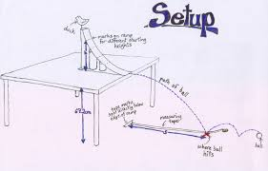

Figure 3.3: Set-up for the experiment.

* We collect the data , release the ball from a point near the top of the ramp, being careful not to impart spin on the ball. This allows the ball to roll down the ramp and bounce on the floor with minimal spin. We repeat the procedure 10 times always releasing ball from the same point on the ramp.
* Now we measure the heights h and H with a meter scale as accurately as possible.
* From the recording paper, we obtain the average values of S1 and S2 in the following way. By eye, we determine the circular region that include most of the marks on the paper (ignore any points that are obviously anomalous). There is drawing the circle around this region. We take the center of the circles for S1 and S2. The radius of the circles as the uncertainties in S1 and S2.
* Then we measure the mass of the marble.

**4. Experimental Data**

Table 3.1: Equations of motion for one dimensional and two dimensional

(projectile) motion

|  |  |  |  |  |  |  |
| --- | --- | --- | --- | --- | --- | --- |
| Height  h    (cm) | Height  H    (cm) | Average  Distance,  S1  (cm) | Uncertainty  in  S1  (cm) | Average  Distance,  S2  (cm) | Uncertainty  in  S2  (cm) | Mass of  Marble  m  (gm) |
| 53 | 15 | 33 | 5.5 | 72 | 10 | 5.7 |

**5. Analysis and Calculation**

1. Time for the ball to leave the ramp and hit the point A, 𝑡 = $\sqrt{\frac{2h}{g}}$ = $\sqrt{\frac{2×53}{981}}$ = 0.3287 s
2. Constant Horizontal velocity of the ball, 𝑣x = = = 100.3955 cm/s
3. Vertical velocity just before it strikes the point A, 𝑣y = −𝑔𝑡 = -(981 $×0.3287)=-322.4547 cm/s$ or 𝑣y = −2𝑔ℎ = − $√$ 2 $×981×53=-$ 322.4686 cm/s
4. Velocity of the ball just before it strikes the point A in vector form

|𝑣| = √𝑣x2 + 𝑣y2= √ (100.3955)2 + (-322.4686)2=337.7355 cm/s

𝜃 = 𝑡𝑎𝑛−1 ( $\frac{v_{y}}{v_{x}}$) = 𝑡𝑎𝑛−1 ( $\frac{322.4686}{100.3955}$) = ${72.7068}^{°}$

1. Range of the second projectile = Distance between point A and B ,

𝑅 = or R= S2 – S1 = 72-33 = 39 cm

1. Time of the ball spends between point A and B, 𝑡ab = = = 0.3885 s
2. Maximum height for the projectile between point A and B,

H = $\frac{g}{2}($ $\frac{t_{ab}}{2})^{2}$ = $\frac{981}{2}($ $\frac{0.3885}{2})^{2}$ = 18.5081 cm

1. Vertical velocity just after it strikes the point A, vy’= tab = 0.3885 =190.5593 cm/s
2. Magnitude of the velocity before/after impact at point A,

|𝑣| = √𝑣x2 + 𝑣y2= √ (100.3955)2 + (190.5593)2=215.3883 cm/s

1. The angle that the ball makes with the surface just before/after the collision at point A,

𝜃 = 𝑡𝑎𝑛−1 ( $\frac{v_{y}}{v_{x}}$) = 𝑡𝑎𝑛−1 ( $\frac{190.5593}{100.3955}$) = ${62.2177}^{°}$

1. Kinetic energy of the ball before the collision at A,

𝐾. 𝐸i = m|𝑣|2= |337.7355|2=325086.0137 gmcm2/s2

1. Kinetic energy of the ball after the collision at A,

𝐾. 𝐸f = m|𝑣’|2= |215.3883|2=132217.5414 gmcm2/s2

1. Horizontal impulse that the floor gives to the ball,

𝐽x = 𝑃ix – 𝑃fx= mvix – mvfx = 572.2544-572.2544=0 gm cm/s

1. Vertical impulse that the floor gives to the ball,

𝐽y = 𝑃iy – 𝑃fy= mviy – mvfy = 1838.01710-1086.1880=751.8830 gm cm/s

**6. Result**

**Table 3.3: Some basic quantities related with projectile motion.**

|  |  |  |  |
| --- | --- | --- | --- |
| SN | Quantities | Corresponding Equations | Value with Units |
| **1** | Time for the ball to leave the ramp and hit the point A | 𝑡 = $\sqrt{\frac{2h}{g}}$ | 0.3287 s |
| **2** | Constant Horizontal velocity of the ball | 𝑣x = | 100.3955 cm/s |
| **3** | Vertical velocity just before it strikes the point A | 𝑣y=−𝑔𝑡 or 𝑣y = −2𝑔ℎ | -322.4547 cm/s |
| **4** | Velocity of the ball just before it strikes the point A in vector form | |𝑣| = √𝑣x2 + 𝑣y2  𝜃 = 𝑡𝑎𝑛−1 ( ) | 337.7355cm/s ${72.7068}^{°}$ |
| **5** | Range of the second projectile = Distance between point A and B | 𝑅 = or R= S2 – S1 | 39 cm |
| **6** | Time of the ball spends between point A and B | 𝑡ab = | 0.3885 s |
| **7** | Maximum height for the projectile between point A and B | H = $\frac{g}{2}($ $\frac{t_{ab}}{2})^{2}$ | 18.5081 cm |

**Table 3.4: Some basic quantities related with elastic collision between ball and the fixed**

**surface.**

|  |  |  |  |
| --- | --- | --- | --- |
| SN | Quantities | Corresponding Equations | Value with Units |
| **1** | Magnitude of the velocity before/after impact at point A | |𝑣| = √𝑣x2 + 𝑣y2 | 215.3883 cm/s |
| **2** | The angle that the ball makes with the surface just before/after the collision at point A | 𝜃 = 𝑡𝑎𝑛−1 ( $\frac{v_{y}}{v_{x}}$) | ${62.2177}^{°}$ |
| **3** | Kinetic energy of the ball before the collision at A | 𝐾. 𝐸i = m|𝑣|2 | 325086.0137gmcm2/s2 |
| **4** | Kinetic energy of the ball after the collision at A | 𝐾. 𝐸f = m|𝑣’|2 | 132217.5414gmcm2/s2 |
| **5** | Horizontal impulse that the floor gives to the ball | 𝐽x = 𝑃ix – 𝑃fx | 0 gm cm/s |
| **6** | Vertical impulse that the floor gives to the ball | 𝐽x = 𝑃ix – 𝑃fx | 751.8830gm cm/s |

**7. Discussion**

1. We should be careful about taking heights.
2. We should be careful about starting point.
3. We should be careful about taking S1 and S2.
4. We have to calculate the value accurately.
5. We should be careful about the release point.
6. The marvel surface is not proper spherical.

**8. References**

* **Fundamental of Physics (10th Edition):** Projectile motion (Chapter 4, page 70 - 75), Collision and Impulse (Chapter 9, page 266)
* **Video Links:**
* Projectile motion: https://www.youtube.com/watch?v=rMVBc8cE5GU
* https://www.youtube.com/watch?v=pZZt357pk-I&list=RDCMUCX1Hh7CvEc3RCUd4NRBWJMw
* https://www.youtube.com/watch?v=WtfVZdpHZ9o
* Collision: https://www.youtube.com/watch?v=hZm-DcO2JfA